- Playing with Numbers:
Ram and Sita are playing with numbers by giving puzzles to each other. Now it was Ram term, so he gave Sita a positive integer ‘n’ and two numbers 1 and 3. He asked her to find the possible ways by which the number n can be represented using 1 and 3.Write any efficient algorithm to find the possible ways.
Example 1:
Input: 6
Output:6
Explanation: There are 6 ways to 6 represent number with 1 and 3
1+1+1+1+1+1
3+3
1+1+1+3
1+1+3+1
1+3+1+1
3+1+1+1
Input Format
First Line contains the number n
Output Format
Print: The number of possible ways ‘n’ can be represented using 1 and 3

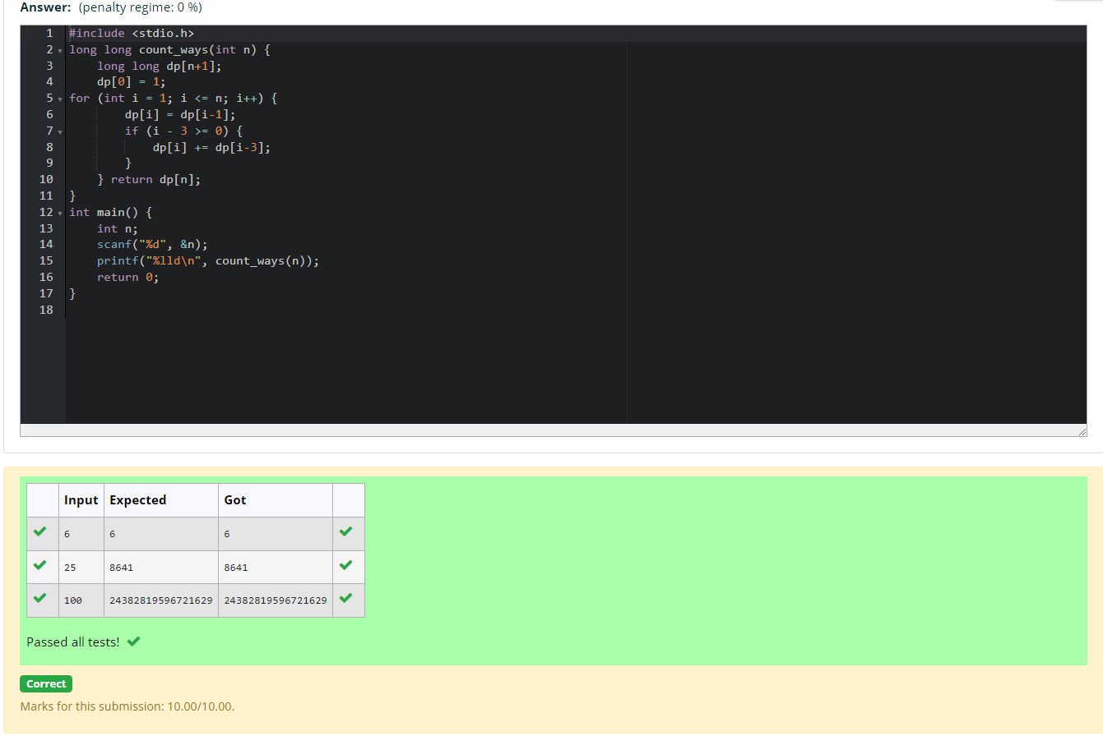

- Playing with Chessboard:
Ram is given with an n*n chessboard with each cell with a monetary value. Ram stands at the (0,0), that the position of the top left white rook. He is been given a task to reach the bottom right black rook position (n-1, n-1) constrained that he needs to reach the position by traveling the maximum monetary path under the condition that he can only travel one step right or one step down the board. Help ram to achieve it by providing an efficient DP algorithm.
Example:
Input
3
1 2 4
2 3 4
8 7 1
Output:
19

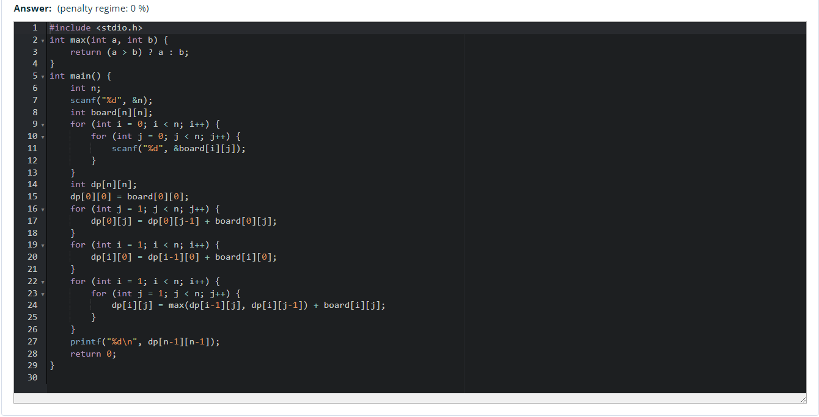
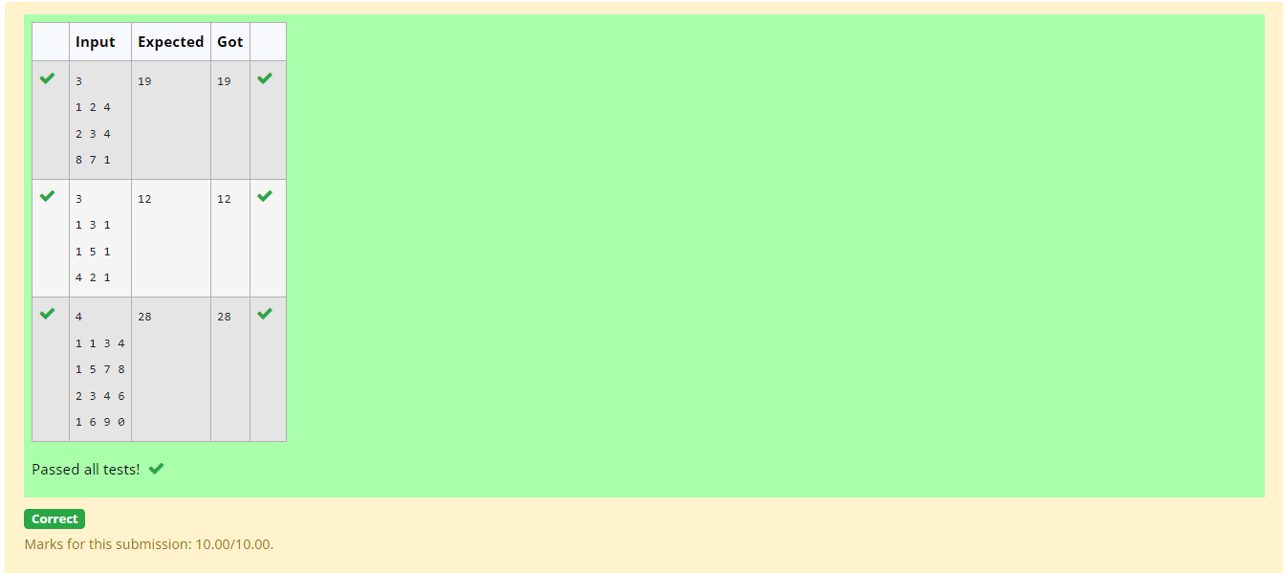
- Given two strings find the length of the common longest subsequence (need not be contiguous) between the two.
Example:
s1: ggtabe
s2: tgatasb

s1 |  | a | g | g | t | a | b
s2 |  | g | x | t | x | a | y | b

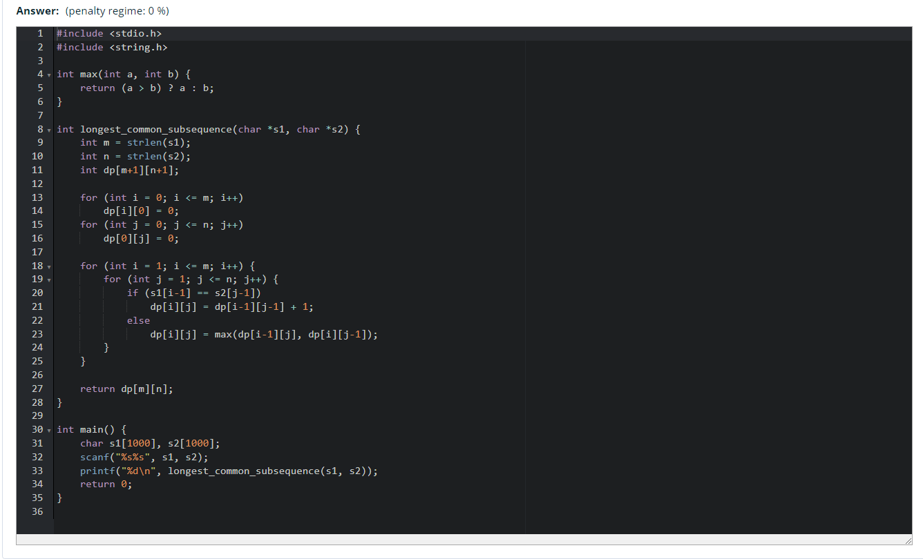

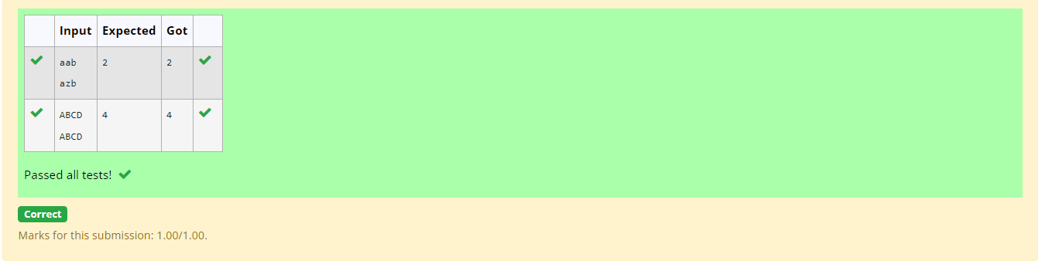

- Problem statement:
Find the length of the Longest Non-decreasing Subsequence in a given Sequence.
Eg:
Input:9
Sequence:[-1,3,4,5,2,2,2,2,3]
the subsequence is [-1,2,2,2,2,3]
Output:6
